SENIORS!

Order Your Class of ‘22 DHS Grad Sign!

Only $30 before 9/30/21

QR code link to online order form:
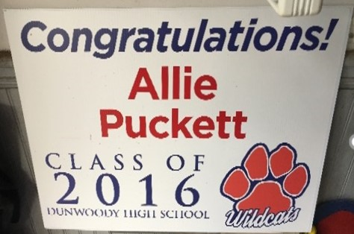

DHS Graduation Sign Order Form

Order your personalized 18x24 sturdy, all-weather yard sign honoring your 2022 graduate. These signs make wonderful mementos for this once-in-a-lifetime event, so show your Wildcat pride!
Please complete and submit the below form. Graduation signs are only $30 if you order by September 30, 2021 (price increases to $40 for orders received after 9/30/21). Please make your payment upon completing this form.
Payment options:
1) Venmo: @Charlie-Hull-2
2) Cash App: $CharlieHull2
3) Checks made payable to the Lady Wildcats Tip-Off Club and drop off with order form or mail to: Charlie Hull, 4847 Parliament Way, Dunwoody, Georgia 30338
For payments by check, please be sure to indicate the name of the student in the memo section of your payment.
We will email instructions on how to pick up your sign after spring break.
Any questions please email dhsladywildcats@gmail.com or call Charlie Hull at 404-569-1101.

Student Name to Appear on Sign: ______________________________________
First Name Only on Sign? (Circle) YES or NO
How Many Signs? __________
Contact Name (Parent or Student):______________________________________
Contact Email: ______________________________________
Contact Phone Number: ______________________________________
Method of Payment: ______________________________________

